Φύλλο εργασίας 8

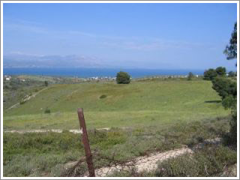
Ο δήμαρχος της περιοχής σκέφτεται ν’ αξιοποιήσει μια μεγάλη έκταση που μέχρι τώρα ήταν ανεκμετάλλευτη. Σας ζητάει να του προτείνετε πολλές εναλλακτικές ιδέες για την αξιοποίησή της.
Χρησιμοποιήστε τη φαντασία σας για να σκεφτείτε και γράψετε πολλές, σύντομες και πρωτότυπες προτάσεις που θα βοηθήσουν στην καλύτερη αξιοποίηση της έκτασης.

___________________________________________________________________________________________________________________________________________________________________________________________________________________________________________________________________________________________________________________________________________________________________________________________________________________________________________________________________________________________________________________________________________________________________________________________________________________________________________________________________________________________________________________________________________________________________________________________________________________________________________________________________________________________________________________________________________________________________________________________________________________________________________________________________________________________________________________________________________________________________________________________________________________________________________________________________________________________________________________________________________________________________________________________________________________________________________________________________________________________________________________________________________________________________________________________________________________________________________________________________________________________________________________________________________________________________________________________________________________________________________________________________________________________________________________________________________________________________________________________________________________________________________________________________________________________________________________________________________________________________________________________________________________________________________________________________________________________________________________________________________________________________________________________________________________________________________________________________________________________________________________________________________________________________________________________________________________________________________________________________________________________________________________________________________________________________________________________________________________________________________________________________________________________________________________________________________________________________________________________________________________________________________________________________________________________________________________________________________________________________________________________________________________________________________________________________________________________________________________________________________________________________________________________________________________________________________________________________________________________________________________________________________________________________________________________________________________________________________________________________________________________________________________________________________________________________________________________________________________________________________________________________________________________________________________________________________________________________________________________________________________________________________________________________________________________________________________________________________________________________________________________________________________________________________________________________________________________________________________________________________________________________________________________________________________________________________________________________________________________________________________________________________________________________________________________________________________________________________________________________________________________________________________________________________
________________________________________________________________________________________________________________________________________

